Our Twenty-Year History

HEC was founded by a group of Hellenes of the Diaspora in March of 1995.

With the advent of the Internet, the Founders had the foresight to appreciate the potential application of this new technology to the benefit of Hellenism. They acquired the domain name Greece.Org, and the Hellenic Electronic Center – an organization by which a sound, well organized, useful, and highly visible presence of Hellenism could be established on the Internet – was born.

The new organization was envisioned as a place for maintaining information about Hellenic civilization and culture, allowing Greeks around the world to access these information resources, communicate with others, and promote Hellenic ideals.

The idea of the HEC originated with the already established Hellas website, part of the Hellas Discussion List (an Internet-based pioneering communication mailing list among university students in the USA since 1989) and the creation of The Poseidon Project, a project about Hellas and The Sea in 1995.

HEC was incorporated in the State of Delaware (USA) on January 23, 1996.

With the help of many volunteers and sponsors, such as Hellas On-Line (HOL), Forthnet and Sysnet, HEC was launched during POSIDONIA '96 International Shipping Exhibition in Piraeus, Greece, in June of 1996.

In April 1997, HEC was recognized as a tax-exempt non-profit educational organization under Section 501(c)(3) of the (US) Internal Revenue Code.

Executive Council

Thanos Voudouris – Maryland, USA
Anna Lawless – London, UK
Stelios Manias – Florida, USA
Eleni Bomis – Montreal, Canada
Fotini Vasileiou – Samos, Greece
Nico Michael – Johannesburg, SA
Marios Chinas – Larnaca, Cyprus
Terry Dritsas – California, USA
Gus Stamatis – Agrinio, Greece
Athanasios Sarantopoulos – Athens, Greece
What you can do

Volunteer: www.greece.org/hec/membership

Donate: www.greece.org/hec/donate/

Hellenic Electronic Center
10201 Grosvenor Place, STE 614
North Bethesda, MD 20852-4611, USA

Web: www.gree.org
eMail: hec@greece.org

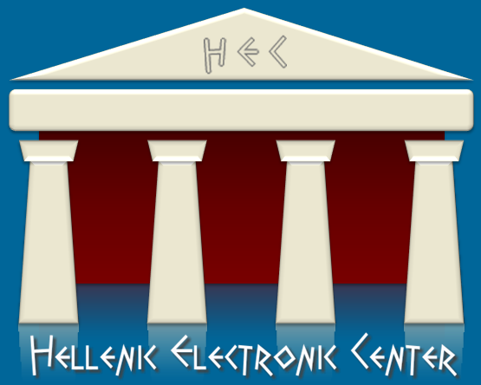
The Hellenism resource

www.greece.org
hec@greece.org

What is the HEC?

The HEC is a worldwide non-profit organization based in the USA.

The HEC promotes Hellenic culture and facilitates the establishment of networks among Hellenes, Philhellenes, and Hellenic organizations around the world.

The HEC assists other non-profit organizations in publishing their projects on the Internet.

The HEC is a nonpartisan organization, without any preference or affiliation to any politically aligned ideology or political party.

The HEC is governed by its Bylaws.

HEC volunteers and officers work on a strictly voluntary basis, without any monetary compensation for their efforts.

All HEC services are provided
FREE of charge worldwide.
Our Objectives

Organize, house and distribute historically, and academically, accurate information regarding all aspects of the Hellenic civilization around the world via the Internet.

Support projects promoting the Hellenic civilization.

Provide computer services to non-profit organizations associated with Greece.

Serve as a communication center for the Greek Diaspora.

Educate and expose Greek society – including the Diaspora – to the culture and technology of the Internet.

Establish scholarships for students who excel in Hellenic studies.

Institute awareness around the world for cultural concerns, such as the return of the Parthenon Marbles back to Greece.

www.greece.org
Some of our Activities & Accomplishments

Repatriation of The Parthenon Marbles – An ongoing campaign to raise awareness of this matter, with the ultimate goal being the return of the Parthenon Marbles to their origins. Please sign the Petition.
http://www.greece.org/blogs/marbles/

WWII Occupation Loan – Petition requesting the German government to honor its long-overdue obligations to Greece by repaying the forcibly obtained occupation loan, and by paying war reparations proportional to the material damages, atrocities, and plundering committed by the German war machine. Please sign the Petition.
http://www.greece.org/blogs/wwii/

Classic Olympics – A project, including a Petition, in cooperation with University of Patras for the revival of the classic Olympiad in Olympia, Greece. Please sign the Petition.
http://www.greece.org/ClassicOlympics/

The Pan-Hellenic Cultural Gathering in Thrace – A three day cultural gathering taking place in Xanthi, Thrace, Greece. The 2016 Gathering will mark the event’s third year, with the help of hundreds of volunteers.
http://www.greece.org/thraki/

HEC provides web hosting and technical expertise to any organization whose objectives are to promote Greece.

