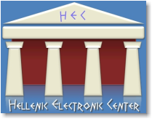 | www.greece.org  A non-profit 501(c)(3) organization registered in USA, EIN 51-0377653

Greek follows

Our Vision

Our vision is to promote Hellenic culture and establish a network among Hellenes, Philhellenes, and Hellenic organizations around the world.

Our Mission

Our mission is to establish a sound, well organized, useful, and highly visible presence of Hellenism on the Internet, providing the means to disseminate information about Hellenism and make available free Electronic services to other Hellenic non-profit organizations and projects focusing on cultural and education aspects.

Our Inspiration

xxxxx

Executive Summary

xxxxxx

